12/04/2022

Replace one record in collection:

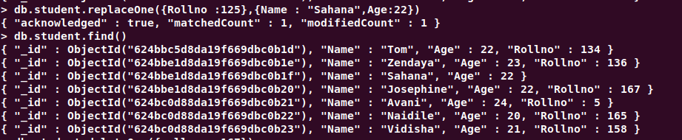

Delete one record:



Delete many record:



Unset:

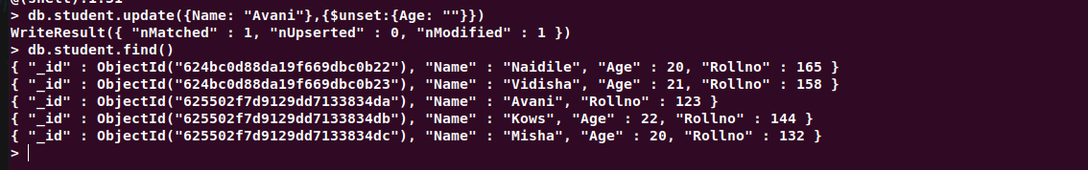

And:



Or:

